|  |  |
| --- | --- |
| DATE | 17 November 2022 |
| TEAM ID | PNT2022TMID34135 |
| PROJECT NAME | IoT based smart crop protection system for agriculture |
| MAXIMUM MARKS | 20 Marks |

**SPRINT :4**

**Configure the Node-RED flow to receive data from the IBM IoT platform and also use Cloudant DB nodes to store the received sensor data in the cloudant DB**

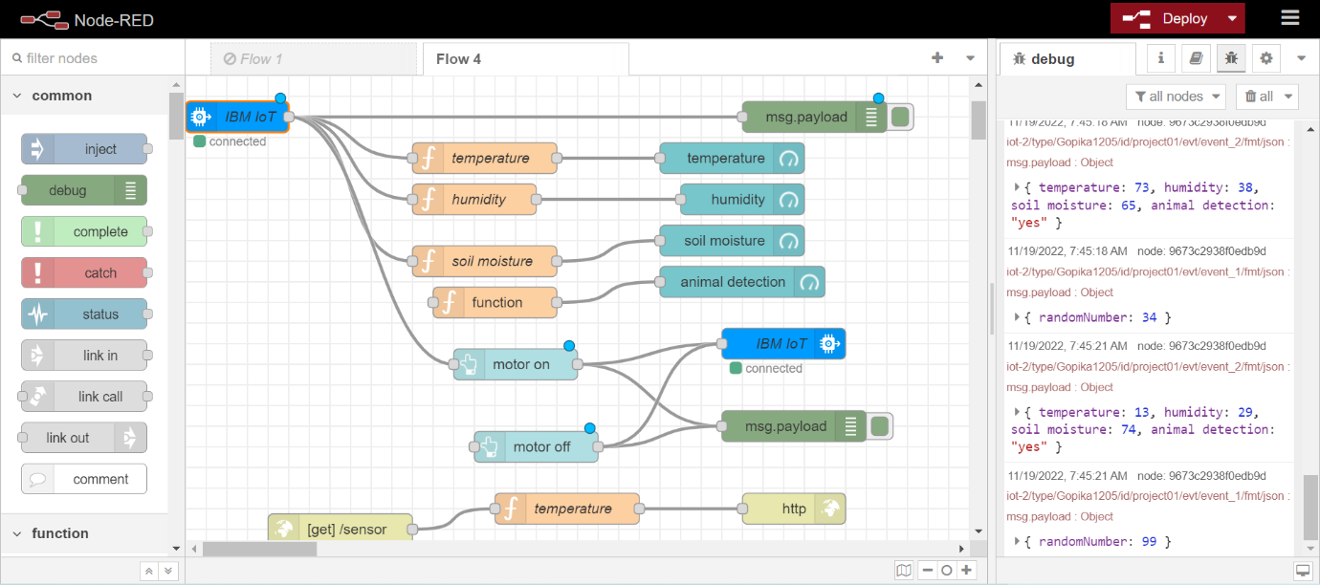

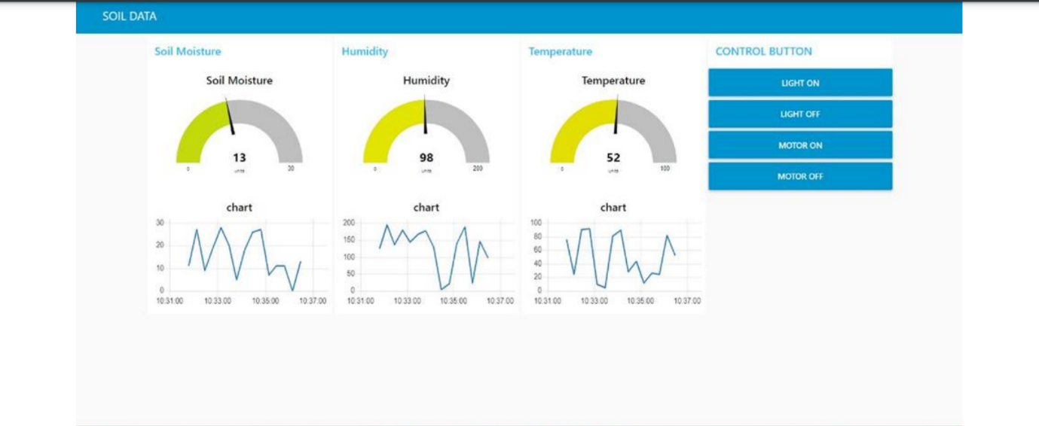

**CLOUDANT DB:**

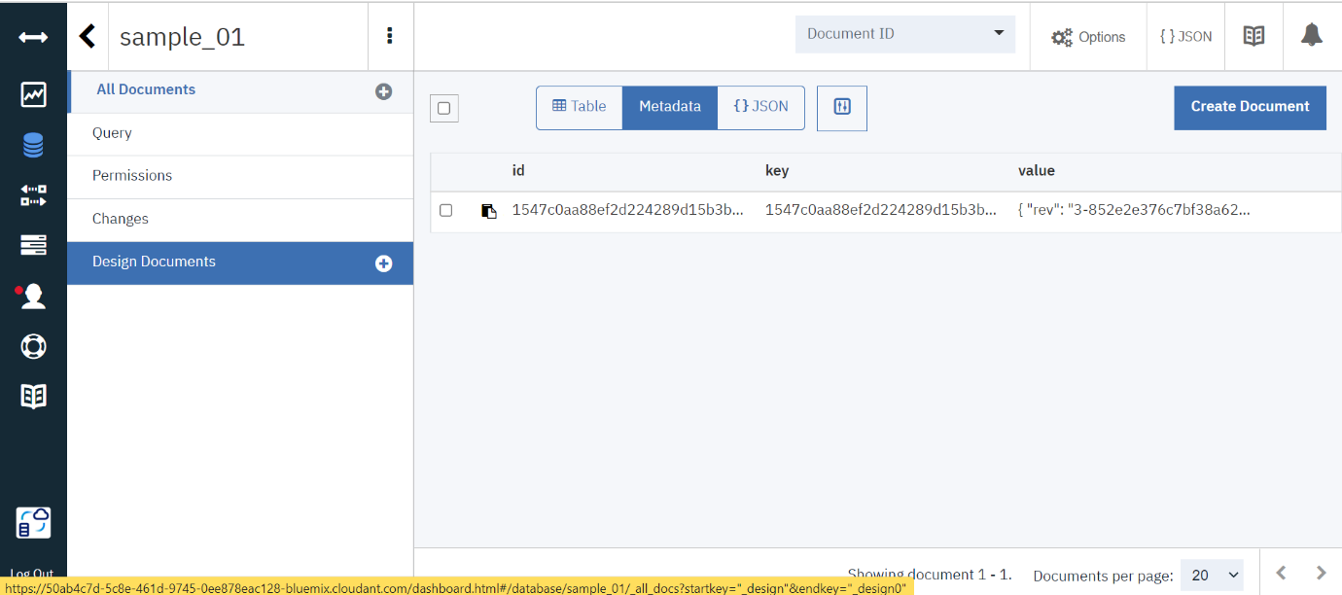

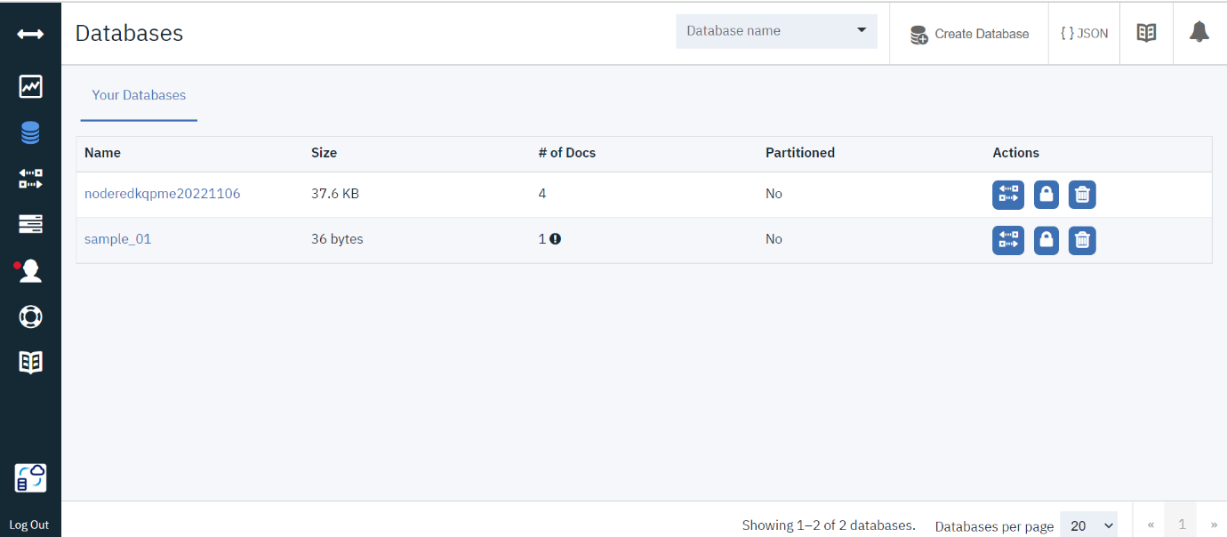

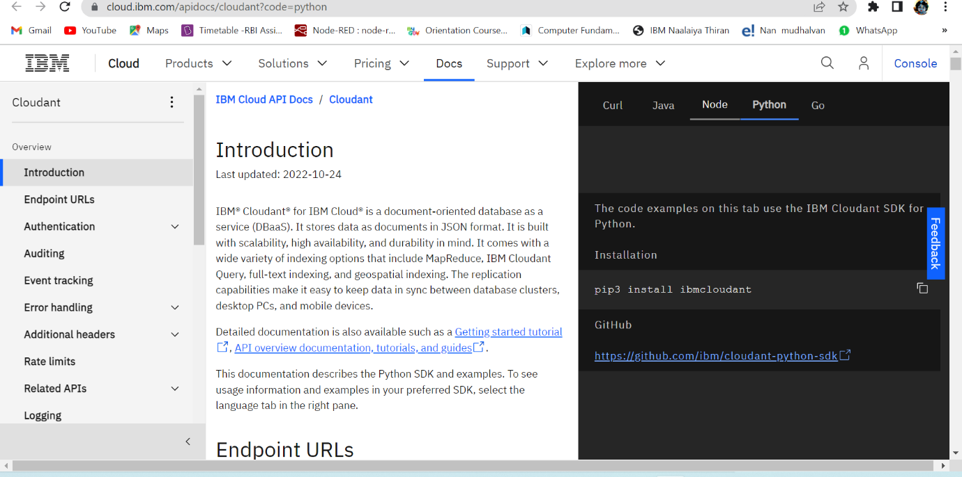

**CLOUDANT STORAGE:**

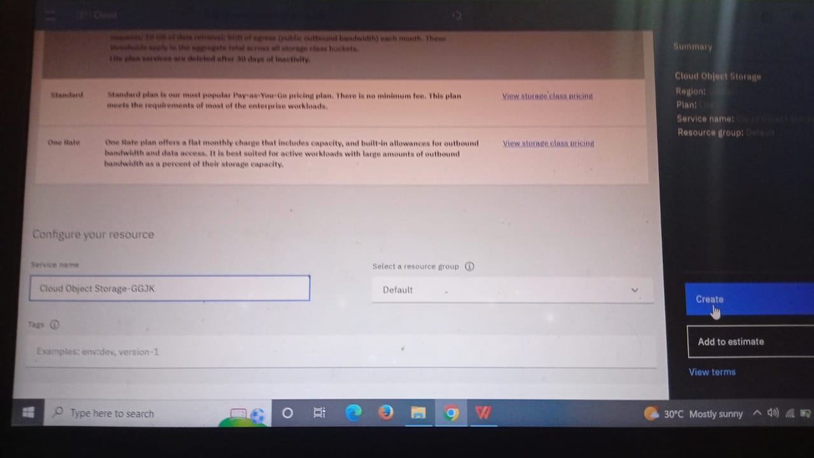

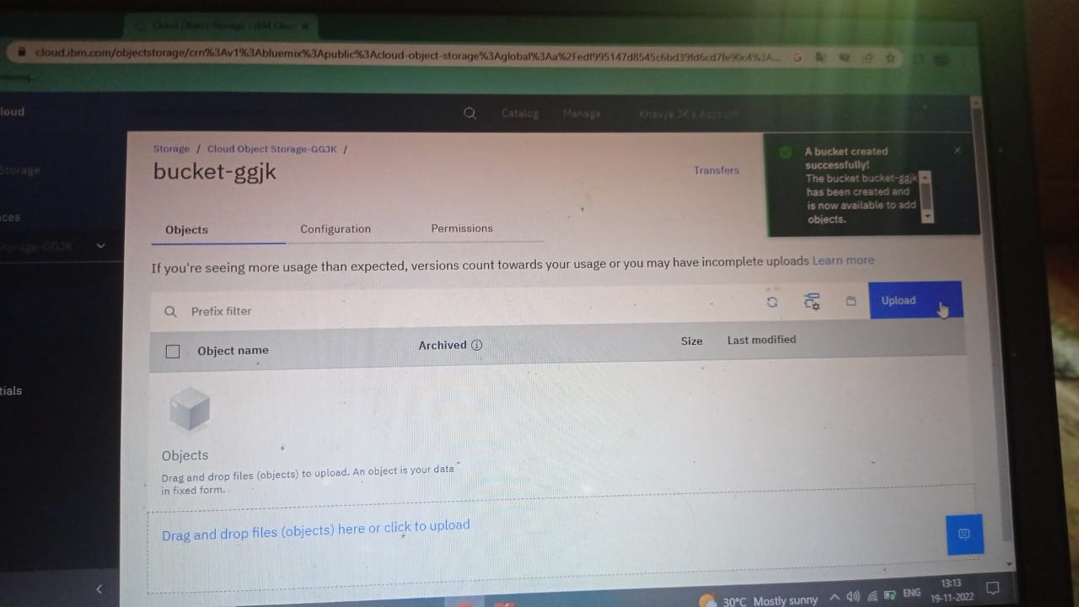

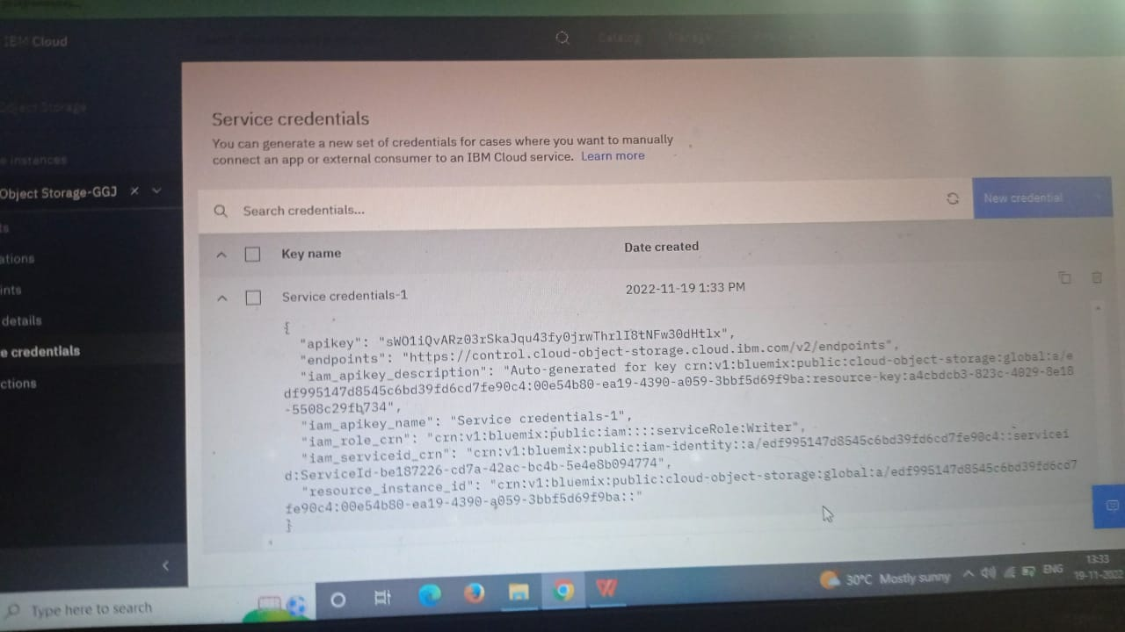

**Create Web UI in Node- Red:**

